

Notes for SMS testing
Author: Nguyen Xuan Tung
Document version: 1.1

Revision History
Rev | Date created | Author | Description of Change
1.0 | 07/23/2018 | Tung Nguyen | Initial version
1.1 | 07/27/2018 | Tung Nguyen | Update for:  - Protocol Identifier (+CSMP)  - New Message Indications to TE (+CNMI)  - Message receiving procedures

Table of Contents

Table of Contents
1. SMS document 4
2. SMS Types (+CMGR, +CMGL) 4
3. SMS Classes and Character Set (+CSMP) 5
4. Protocol Identifier (+CSMP) 8
5. New Message Indications to TE (+CNMI) 10
6. Message receiving procedures 12
7. Message service send and write procedures 14

SMS document
3GPP TS 27.005: AT Command
3GPP TS 23.040: Technical realization

SMS Types (+CMGR, +CMGL)
  - SMS Types:
GSM 03.40 defines six types of messages, which are distinguished by the message direction and the two least significant bits in the first octet of SM-TP message (the TP-MTI field):

Direction Message type
MS → SC SMS-DELIVER-REPORT
SC → MS SMS-DELIVER
MS → SC SMS-SUBMIT
SC → MS SMS-SUBMIT-REPORT
MS → SC SMS-COMMAND
SC → MS SMS-STATUS-REPORT

SMS-SUBMIT is used to submit a short message from a mobile phone (Mobile Station, MS) to a short message service centre (SMSC, SC).

SMS-SUBMIT-REPORT is an acknowledgement to the SMS-SUBMIT; a success means that the message was stored (buffered) in the SMSC, a failure means that the message was rejected by the SMSC.

SMS-COMMAND may be used to query for a message buffered in the SMSC, to modify its parameters or to delete it.

SMS-DELIVER is used to deliver a message from SMSC to a mobile phone. The acknowledgement returned by the mobile phone may optionally contain a SMS-DELIVER-REPORT. When home routing applies, SMS-DELIVER is used to submit messages from an SMSC to another one.

SMS-STATUS-REPORT may be sent by the SMSC to inform the originating mobile phone about the final outcome of the message delivery or to reply to a SMS-COMMAND.
  - Execution with AT Command:
Please check about type of SMS when executing +CGMR and +CGML. The different SMS types have the different displays
+CMGR=<index> | if text mode (+CMGF=1), command successful and SMS-DELIVER:  +CMGR: <stat>,<oa>,[<alpha>],<scts>[,<tooa>,<fo>,<pid>,<dcs>,  <sca>,<tosca>,<length>]<CR><LF><data>  if text mode (+CMGF=1), command successful and SMS-SUBMIT:  +CMGR: <stat>,<da>,[<alpha>][,<toda>,<fo>,<pid>,<dcs>,[<vp>],  <sca>,<tosca>,<length>]<CR><LF><data>  if text mode (+CMGF=1), command successful and SMS-STATUS-REPORT:  +CMGR: <stat>,<fo>,<mr>,[<ra>],[<tora>],<scts>,<dt>,<st>  if text mode (+CMGF=1), command successful and SMS-COMMAND:  +CMGR: <stat>,<fo>,<ct>[,<pid>,[<mn>],[<da>],[<toda>],<length>  <CR><LF><cdata>]  if text mode (+CMGF=1), command successful and CBM storage:  +CMGR: <stat>,<sn>,<mid>,<dcs>,<page>,<pages><CR><LF><data>  otherwise:  +CMS ERROR: <err>
+CMGL[=<stat>] | if text mode (+CMGF=1), command successful and SMS-SUBMITs and/or SMS-DELIVERs:  +CMGL: <index>,<stat>,<oa/da>,[<alpha>],[<scts>][,<tooa/toda>,  <length>]<CR><LF><data>[<CR><LF>  +CMGL: <index>,<stat>,<da/oa>,[<alpha>],[<scts>][,<tooa/toda>,  <length>]<CR><LF><data>[...]]  if text mode (+CMGF=1), command successful and SMS-STATUS-REPORTs:  +CMGL: <index>,<stat>,<fo>,<mr>,[<ra>],[<tora>],<scts>,<dt>,<st>  [<CR><LF>  +CMGL: <index>,<stat>,<fo>,<mr>,[<ra>],[<tora>],<scts>,<dt>,<st>  [...]]  if text mode (+CMGF=1), command successful and SMS-COMMANDs:  +CMGL: <index>,<stat>,<fo>,<ct>[<CR><LF>  +CMGL: <index>,<stat>,<fo>,<ct>[...]]  if text mode (+CMGF=1), command successful and CBM storage:  +CMGL: <index>,<stat>,<sn>,<mid>,<page>,<pages>  <CR><LF><data>[<CR><LF>  +CMGL: <index>,<stat>,<sn>,<mid>,<page>,<pages>  <CR><LF><data>[...]]  otherwise:  +CMS ERROR: <err>

SMS Classes and Character Set (+CSMP)
SMS Classes and Character Set is configured in <dcs> Data Coding Scheme by +CSMP (text mode) or PDU SMS string (PDU mode)
For full range of <dcs>, please refer to 3GPP 23.038 (SMS Data Coding Scheme) or https://en.wikipedia.org/wiki/Data_Coding_Scheme
Example:
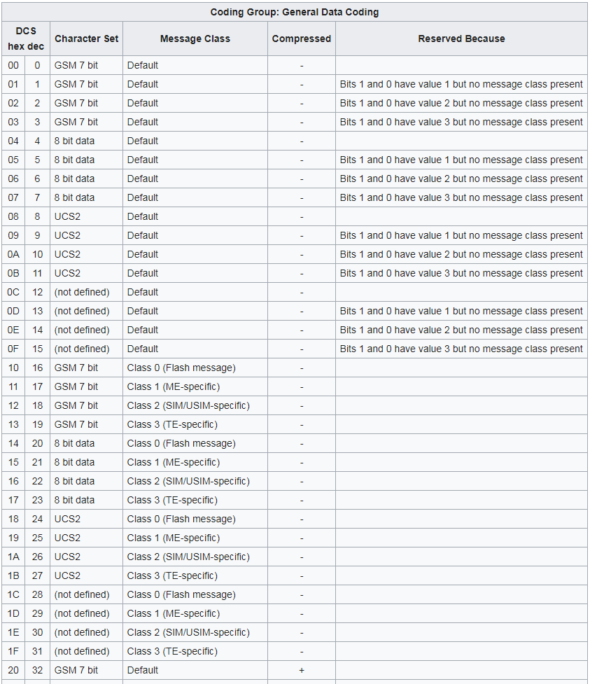
Note: The supported <dcs> is dependent on the specific network
  - SMS Classes
SMS Classes is defined in 3GPP TS 23.038 (in SMS Data Coding Scheme)
- Class 0: (short definition: This type of SMS message is displayed on the mobile screen without being saved in the message store or on the SIM card; unless explicitly saved by the mobile user or the case in the below red lines)
When a mobile terminated message is class 0 and the MS has the capability of displaying short messages, the MS shall display the message immediately and send an acknowledgement to the SC when the message has successfully reached the MS irrespective of whether there is memory available in the (U)SIM or ME. The message shall not be automatically stored in the (U)SIM or ME.
The ME may make provision through MMI for the user to selectively prevent the message from being displayed immediately.
If the ME is incapable of displaying short messages or if the immediate display of the message has been disabled through MMI then the ME shall treat the short message as though there was no message class, i.e. it will ignore bits 0 and 1 in the TP-DCS and normal rules for memory capacity exceeded shall apply.
- Class 1: (short definition: This message is to be stored in the device memory or the SIM card (depending on memory availability))
When a mobile terminated message is Class 1, the MS shall send an acknowledgement to the SC when the message has successfully reached the MS and can be stored. The MS shall normally store the message in the ME by default, if that is possible, but otherwise the message may be stored elsewhere, e.g. in the (U)SIM. The user may be able to override the default meaning and select their own routing.
- Class 2: (short definition: This message class carries SIM card data. The SIM card data must be successfully transferred prior to sending acknowledgment to the service center. An error message is sent to the service center if this transmission is not possible. SMS is saved in SIM)
When a mobile terminated message is Class 2 ((U)SIM-specific), an MS shall ensure that the message has been transferred to the SMS data field in the (U)SIM before sending an acknowledgement to the SC. The MS shall return a "protocol error, unspecified" error message (see 3GPP TS 24.011 [6]) if the short message cannot be stored in the (U)SIM and there is other short message storage available at the MS. If all the short message storage at the MS is already in use, the MS shall return "memory capacity exceeded". This behaviour applies in all cases except for an MS supporting (U)SIM Application Toolkit when the Protocol Identifier (TP-PID) of the mobile terminated message is set to "(U)SIM Data download" (see 3GPP TS 23.040 [4]).
- Class 3: (short definition: This message is forwarded from the receiving entity to an external device. The delivery acknowledgment is sent to the service center regardless of whether or not the message was forwarded to the external device.)
When a mobile terminated message is Class 3, the MS shall send an acknowledgement to the SC when the message has successfully reached the MS and can be stored, irrespectively of whether the MS supports an SMS interface to a TE, and without waiting for the message to be transferred to the TE. Thus the acknowledgement to the SC of a TE-specific message does not imply that the message has reached the TE. Class 3 messages shall normally be transferred to the TE when the TE requests "TE-specific" messages (see 3GPP TS 27.005 [8]). The user may be able to override the default meaning and select their own routing.
  - Character Set
GSM recognizes only two encodings for text messages and one encoding for binary messages:
- GSM 7-bit default alphabet: Support of the GSM 7-bit alphabet is mandatory for GSM handsets and network elements
- UCS-2: Languages which use Latin script, but use characters which are not present in the GSM 7-bit default alphabet, often replace missing characters with diacritic marks with corresponding characters without diacritics, which causes not entirely satisfactory user experience, but is often accepted. In order to include these missing characters the 16-bit UTF-16 (in GSM called UCS-2) encoding may be used at the price of reducing the length of a (non-segmented) message from 160 to 70 characters.
- 8-bit data

Protocol Identifier (+CSMP)
Protocol Identifier is configured in <pid> by +CSMP (text mode) or PDU SMS string (PDU mode)
TP-PID (Protocol identifier) either refers to the higher layer protocol being used, indicates interworking with a certain type of telematic device (like fax, telex, pager, teletex, e-mail), specifies replace type of the message or allows download of configuration parameters to the SIM card. Plain MO-MT messages have PID=0.
TP-PID | Meaning
0 | Default store and forward short message
1–31 | no telematic interworking, but SME to SME protocol
32 | implicit telemetic device
33 | Telex or teletex reduced to telex format
34 | Group 3 telefax
35 | Group 4 telefax
36 | Voice telephone
37 | ERMES (European Radio Messaging System)
38 | National Paging system (known to the SC)
39 | Videotex (T.100 [20] /T.101 [21])
40 | Teletex, carrier unspecified
41 | Teletex, in PSPDN
42 | Teletex, in CSPDN
43 | Teletex, in analog PSTN
44 | Teletex, in digital ISDN
45 | UCI (Universal Computer Interface, ETSI DE/PS 3 01 3)
46–47 | Reserved
48 | A message handling facility (known to the SC)
49 | Any public X.400 based message handling system
50 | Internet Electronic Mail
51–55 | Reserved
56–62 | SC-specific; usage based on mutual agreement between the SME and the SC
63 | A GSM/UMTS mobile station.
64 | Short Message Type 0
65 | Replace Short Message Type 1
66 | Replace Short Message Type 2
67 | Replace Short Message Type 3
68 | Replace Short Message Type 4
69 | Replace Short Message Type 5
70 | Replace Short Message Type 6
71 | Replace Short Message Type 7
72 | Device Triggering Short Message
73–93 | Reserved
94 | Enhanced Message Service (Obsolete)
95 | Return Call Message
96–123 | Reserved
124 | ANSI-136 R-DATA
125 | ME Data download
126 | ME De personalization Short Message
127 | (U)SIM Data download
128–191 | reserved
192–255 | Assigns bits 0 5 for SC specific use
For TP-PID = 63 the SC converts the SM from the received TP Data Coding Scheme to any data coding scheme supported by that MS (e.g. the default).

Note for some important Protocol Identifier:
- A short message type 0 indicates that the ME must acknowledge receipt of the short message but shall discard its contents. This means that
- the MS shall be able to receive the type 0 short message irrespective of whether there is memory available in the (U)SIM or ME or not,
- the MS shall not indicate the receipt of the type 0 short message to the user,
- the short message shall neither be stored in the (U)SIM nor ME.
- Replace Short Message
The Replace Short Message feature is optional for the ME and the (U)SIM but if implemented it shall be performed as described here.

For MT short messages, on receipt of a short message from the SC, the MS shall check to see if the associated Protocol Identifier contains a Replace Short Message Type code.

If such a code is present, then the MS shall check the originating address and replace any existing stored message having the same Protocol Identifier code and originating address with the new short message and other parameter values. If there is no message to be replaced, the MS shall store the message in the normal way. The MS may also check the SC address as well as the Originating Address. However, in a network which has multiple SCs, it is possible for a Replace Message type for a SM to be sent via different SCs and so it is recommended that the SC address should not be checked by the MS unless the application specifically requires such a check.

If a Replace Short Message Type code is not present then the MS shall store the message in the normal way

- For other Protocol Identifier, please refer to 3GPP TS 23.040 (9.2.3.9 TP-Protocol-Identifier (TP-PID))

New Message Indications to TE (+CNMI)

Command | Possible response(s)
+CNMI=[<mode>[,<mt>[,<bm>[,<ds>[,<bfr>]]]]] | +CMS ERROR: <err>
+CNMI? | +CNMI: <mode>,<mt>,<bm>,<ds>,<bfr>
+CNMI=? | +CNMI: (list of supported <mode>s),(list of  supported <mt>s),(list of supported <bm>s),(list of  supported <ds>s),(list of supported <bfr>s)
Description
Set command selects the procedure, how receiving of new messages from the network is indicated to the TE when TE is active, e.g. DTR signal is ON. If TE is inactive (e.g. DTR signal is OFF), message receiving should be done as specified in 3G TS 23.038 [2].
NOTE: When DTR signal is not available or the state of the signal is ignored (V.25ter command &D0), reliable message transfer can be assured by using +CNMA acknowledgement procedure.
For detail parameters, please refer to 3GPP TS 27.005 (3.4.1 New Message Indications to TE +CNMI). Below is summary:
<mode> controls the processing of unsolicited result codes specified within this command
<mt> sets the result code indication routing for SMS-DELIVERs
<mt> | result codes and commands
0 | No SMS-DELIVER indications are routed to the TE
1 | If SMS-DELIVER is stored into ME/TA, indication of the memory location is routed to the TE using unsolicited result code:  +CMTI: <mem>,<index>
2 | SMS-DELIVERs (except class 2 messages and messages in the message waiting indication group (store message)) are routed directly to the TE using unsolicited result code:  +CMT: [<alpha>],<length><CR><LF><pdu> (PDU mode enabled)  or  +CMT: <oa>, [<alpha>],<scts>[,<tooa>,<fo>,<pid>,<dcs>,<sca>,<tosca>,  <length>]<CR><LF><data> (text mode enabled; about parameters in italics, refer command Show Text Mode Parameters +CSDH)  If ME has its own display device then class 0 messages and messages in the message waiting indication group (discard message) may be copied to both ME display and to TE. In this case, ME shall send the acknowledgement to the network (refer table 2).  Class 2 messages and messages in the message waiting indication group (store message) result in indication as defined in <mt>=1.
3 | Class 3 SMS-DELIVERs are routed directly to TE using unsolicited result codes defined in <mt>=2. Messages of other data coding schemes result in indication as defined in <mt>=1

<bm> sets the result code indication routing for CBMs (cell broadcast messages)
<bm> | result codes and commands
0 | No CBM indications are routed to the TE
1 | If CBM is stored into ME/TA, indication of the memory location is routed to the TE using unsolicited result code:  +CBMI: <mem>,<index>
2 | New CBMs are routed directly to the TE using unsolicited result code:  +CBM: <length><CR><LF><pdu> (PDU mode enabled)  or  +CBM: <sn>,<mid>,<dcs>,<page>,<pages><CR><LF><data> (text mode enabled)  If ME supports data coding groups which define special routing also for messages other than class 3 (e.g. (U)SIM  specific messages), ME may choose not to route messages of such data coding schemes into TE (indication of a  stored CBM may be given as defined in <bm>=1)
3 | Class 3 CBMs are routed directly to TE using unsolicited result codes defined in <bm>=2. If CBM storage issupported, messages of other classes result in indication as defined in <bm>=1

<ds> sets the result code indication routing for SMS-STATUS-REPORTs
<ds> | result codes and commands
0 | No SMS-STATUS-REPORTs are routed to the TE
1 | SMS-STATUS-REPORTs are routed to the TE using unsolicited result code:  +CDS: <length><CR><LF><pdu> (PDU mode enabled)  or  +CDS: <fo>,<mr>,[<ra>],[<tora>],<scts>,<dt>,<st> (text mode enabled)
2 | If SMS-STATUS-REPORT is stored into ME/TA, indication of the memory location is routed to the TE usingunsolicited result code:  +CDSI: <mem>,<index>

<bfr> defines the handling method for buffered result codes when <mode> 1, 2 or 3 is enabled.
If ME does not support requested item (although TA does), final result code +CMS ERROR: <err> is returned. See chapter Message Service Failure Result Code for a list of <err> values.
Test command gives the settings supported by the TA as compound values.
NOTE: Command Select Message Service +CSMS should be used to detect ME support of mobile terminated SMs and CBMs, and to define whether a message routed directly to TE should be acknowledged or not (refer command +CNMA).

Message receiving procedures
Message forwarding is done as illustrated in the below figure. Optional +CNMA acknowledgement procedure is not presented. In this example, there is no TA memory for messages and result code buffer is situated in TA. The routing of message waiting indication group (discard message) SMS-DELIVERs equal to class 0 messages, and the routing of message waiting indication group (store message) SMS-DELIVERs equal to class 2 messages.
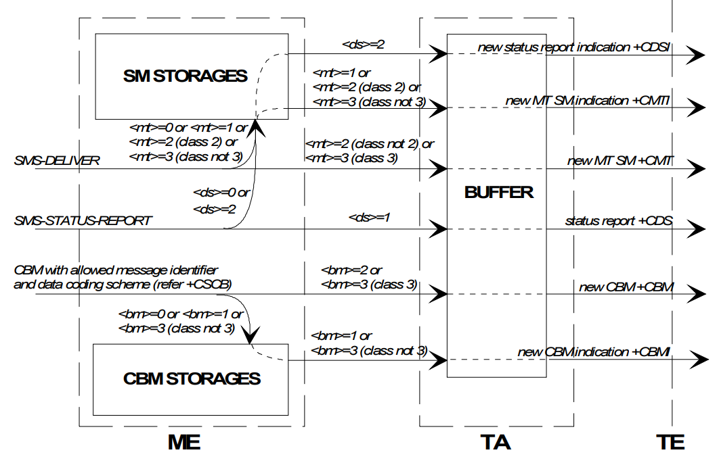

According to the configuration of +CNMI and the class of SMS, the suitable URC will be shown when the new SMS is received.
Note 1:
- If SMS-DELIVER is stored in ME, URC +CMTI will be shown
- If SMS-DELIVERs are routed directly to the TE, URC CMT will be shown
Note 2:
- SMS-DELIVER, SMS-STATUS-REPORT, CBM is the received SMS. They are dependent on mobile network about existence and format.
- +CDSI, +CMTI, +CMT, +CDS, +CBM are URCs. They are dependent on +CNMI command.
Example:
Setting new message indications:

AT+CNMI=? (query new message unsolicited result code modes)
+CNMI: (0-2),(0-3),(0-3),(0,1),(0,1)
OK
AT+CNMI=2,1,0,1,0(send SM and status report indications to TE
OK when TA in command mode, otherwise buffer)

In this example, the TA is set so that it should send an unsolicited result code +CMTI: <mem>,<index> to the TE when a new SMS-DELIVER is received from the network and stored successfully to storage <mem>, and an unsolicited result code +CDS:... when a SMS-STATUS-REPORT is received. These result codes are routed to the TE when TA is in command mode, but buffered when in on-line data mode. Now, if new SM is received, it can be read as follows (text mode with no detailed header information; GSM 7 bit default alphabet used in message body):

+CMTI: "ME",2 (new message received in index 2)
AT+CMGR=2 (read the message)
+CMGR: "REC UNREAD","+358507654321","Mr.Jones","95/07/03,17:38:15+04"
This is the Mr. Jones testing
OK

In the next example all messages of storage <mem1> are listed (text mode with no detailed header information; GSM 7 bit default alphabet used in message bodies):

AT+CMGL="ALL" (read all SMs)
+CMGL: 1,"REC READ","+358501234567","Mr. Smith","95/07/03,17:45:03+04"
This is the body of the message.
+CMGL: 2,"STO UNSENT","+358501234567","Mr. Smith",
This is the body of the reply.
OK

The next example shows a method to read new CBMs received from the network (text mode; GSM 7 bit default alphabet used in message bodies):

AT+CNMI=2,,2,,0 (CBMs will be sent to the TE)
OK
AT+CPMS="BM";+CMGL (select CBM memory for reading; list all unread CBMs)
+CMGL: 1,"REC UNREAD",100,40,1,3 (first page of three page weather information)
Weather in Finland 3rd of July 1995
+CMGL: 2,"REC UNREAD",100,40,2,3 (second page of three page weather information)
Helsinki: cloudy, snow storms, -20 degrees Celsius, wind -14 m/s NE
+CMGL: 3,"REC UNREAD",100,40,3,3 (third page of three page weather information)
Tampere: sunny, 40 degrees Celsius, wind 1 m/s SW
OK

Message service send and write procedures
The below figure is an example of a TE-TA-ME setup when messages are sent to network or stored to ME. The volatile memory may as well be in the ME, or a non-volatile memory may be used instead when constructing messages.
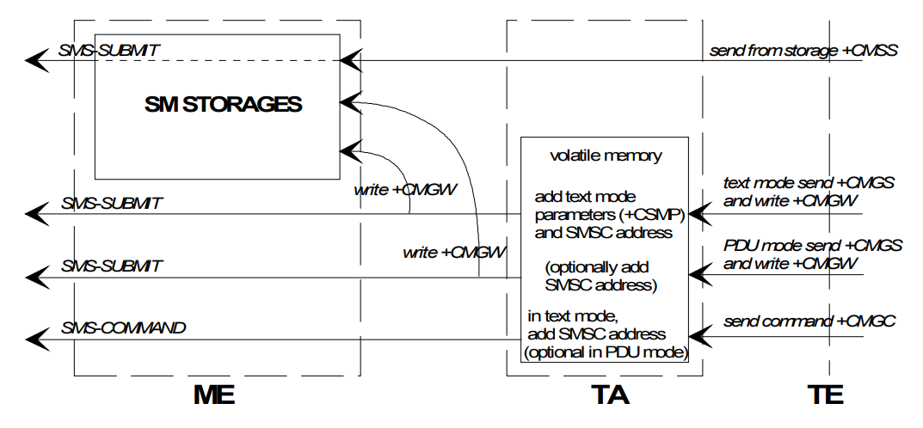
Example:
An example of sending a GSM 7 bit default alphabet message in text mode and a SMS-STATUS-REPORT is wanted:

AT+CNMI? (check that status reports are routed to TE)
+CNMI: 2,1,0,1,0
OK
AT+CSMP=49,167,0,0 (status report wanted; otherwise default settings)
OK
AT+CMGS="+358501234567" (start editing a message)
> This the first line. (edit first line and press carriage return)
> This is the last line.^Z (edit second line and send message by pressing control-Z)
+CMGS: 10 (success: message reference 10 returned from SMSC)
OK
+CDS: 2,10,"+358501234567",145,"95/07/04/13:12:14+04",
"95/07/04/13:12:20+04",0 (status report of successful message delivery received)

Storing an unsent message in memory, sending it from there, and deleting it:

AT+CPMS? (check memory settings)
+CPMS: "ME",4,10,"ME",4,10,"ME",4,10
OK
AT+CMGW="9501231234" (write message)
> This is the message body^Z
+CMGW: 7 (index number in storage returned)
OK
AT+CMSS=7 (send from storage)
+CMSS: 12 (success: reference value 12 sent from SC)
OK
AT+CMGD=7 (delete message)
OK

